Bin Assignment的设计

Bin 是分配给Rig的，它随着Rig一起进入下一个Rig Job，所以无论Rig的状态是什么，Bin都可能会和它绑在一起。典型的场景是，一个rig上的job结束了，因为天气原因，它被标记为非活动状态，但是Bin还是和它在一起，Sanjel要采取一个主动动作去把这个Bin运回来。

还有其他的业务场景，可以预见将来会有更多的业务需求与此相关，目前还不是非常清晰。所以在设计时尽量不对其他实体进行扩展。而是对关联进行单独定义。

实体定义： BinAssignment

数据库定义： 数据库表 BinAssignment，只包含Bin和Rig的最基本关联信息。

微服务定义：

* GetBinCollectionByRigId
* AssignBinToRig
* UnassignBinToRig

业务用例：

1. Need Bin
   1. A rig has no bin assigned, dispatcher is able to mark the current rig job on rig board “Need Bins”.
   2. If a rig needs more bins assigned, dispatcher just continue to add more bins,
   3. “Need Bins” flag can be removed by dispatcher to uncheck the rig job when there is no bin assigned.
   4. “Need Bins” flag can be removed by releasing the bins from a rig until no bin is assigned
2. Assign a Bin

Dispatcher is able to assign a bin to a rig through operation on Rig Board.

If the rig job is not completed, when a bin is assigned, the corresponding bin section needs to be inserted into call sheet.

1. Release a Bin

Dispatcher is able to remove a bin assignment from a rig through operation on Rig Board.

If the rig job is not completed, when a bin is released, the corresponding bin section needs to be removed from call sheet.

1. Carry on bins

When a rig job is created, the bins assigned to the rig will be carried over to the Call Sheet.

Current implementation: Creating call sheet in eService is the start point of the rig job, dispatcher doesn’t want to enter the bin information manually , the bin sections need to be inserted while saving the call sheet.

Need to confirm: When create call sheet, the bin sections need to display, user can add or remove a bin. Here need to add a wcf service to implement the function.

Answer by Viktor: - Call sheets in eService mainly are created by dispatchers. So, I do not think we need to enforce them to populate bin section during creation. It should be up to them when they prefer to enter bin data – in eService during creating call sheet / editing it or using Rig Board. So, I would say, no changes to eService in relation to Bin Section handling.

Future implementation: Call sheet will be created on Rig Board.

补充说明：

Rig Job中的Bin Section只是facade，不需要存数据库。在Rig Board上Assign a bin时是建立Rig和Bin的关联。

每生成一个call sheet时，根据assignment 给call sheet添加bin section。

TODO List:

1. Revert the previous changes in Bin Section.

Need to confirm:

1. Revert the previous changes in Bin Section include :
   1. Delete the Need bins 、Number of Bin
   2. Delete the validation for Number of bin in call sheet

Answer by Viktor: - I did not check code, but if it was removed from eService, yes, please revert changes.

Need to confirm:

1. When create Call Sheet in eService, the bin sections need to be inserted while saving the call sheet. Dispatcher doesn’t want to enter the bin information manually.

Add and Remove functions are same as in Online. When add a bin will trigger two operations at the same time:

1) Add a record in BinAssignment for the Bin with current rig;

2) Add a Bin Section

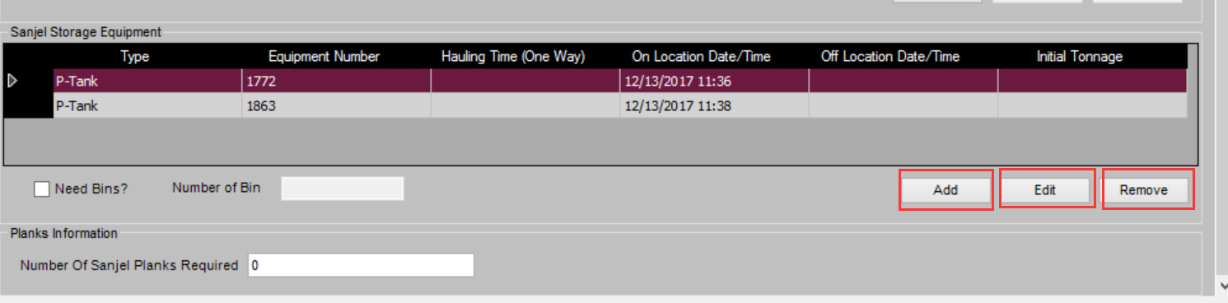

Answer by Viktor: - I discussed it briefly with business and the opinion is do not change the Bin Section in eService.

Answer by Adam: - Don’t disable any eService winform feature until you are told to do so. You may have to add a flag in the section, so you may know if the record is added from online actions. The online sections must be selft-contained.

1. The Edit function:

If change the Bin Number, this will trigger two operations at the same time:

1) Modify BinAssignment for the Bin with current rig;

2) Modify the Bin Section;